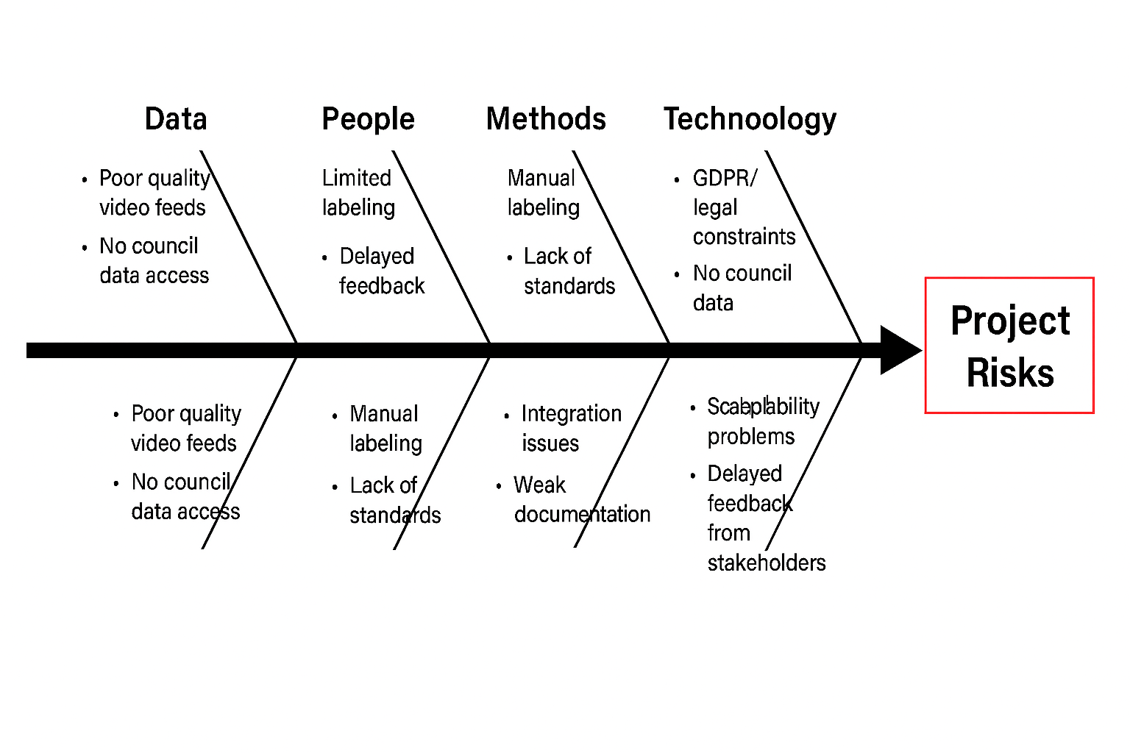
Risk Management Table
Risk ID | Risk Description | Impact | Likelihood | Response Type | Mitigation Strategy
R1 | Privacy concerns (GDPR compliance) | High | Medium | Control | Anonymise data, restrict access, ensure GDPR compliance and secure storage
R2 | Poor quality video data | Medium | High | Control | Apply preprocessing, optimise model for low-resolution input
R3 | Limited labelled data | High | High | Control | Use transfer learning, augmentation, and manual labelling
R4 | No access to council CCTV data | High | Medium | Accept | Use public datasets and simulated data; document limitations
R5 | Environmental variability | Medium | High | Control | Train on diverse data, apply augmentation, optimise thresholds
R6 | High false positives | High | Medium | Control | Tune thresholds, improve dataset, refine model
R7 | High false negatives | High | Medium | Control | Improve recall through tuning and dataset expansion
R8 | Real-time performance issues | High | Medium | Control | Use lightweight models, optimise processing and FPS
R9 | Integration issues (AI + backend + dashboard) | Medium | Medium | Control | Modular design, frequent integration testing
R10 | Scalability limitations | High | Medium | Control | Design scalable architecture, optimise data handling
R11 | Hardware limitations (no GPU) | Medium | High | Accept | Optimise for CPU, reduce model complexity
R12 | Stakeholder feedback delays | Medium | Medium | Accept | Schedule meetings, proceed iteratively if needed
R13 | Model overfitting | Medium | Medium | Control | Use validation, regularisation, cross-validation
R14 | Data imbalance | Medium | High | Control | Apply resampling, class weighting
R15 | Ethical misuse of system | High | Low | Avoid | Define strict usage policies, restrict access, ensure transparency
R16 | Dashboard performance issues | Medium | Medium | Control | Optimise queries, reduce data load, implement caching
R17 | Poor dashboard usability | Medium | Medium | Control | Apply user-centred design, gather stakeholder feedback
R18 | Failure of real-time dashboard updates | High | Medium | Control | Use asynchronous processing and efficient pipelines
R19 | Inaccurate event logging | High | Medium | Control | Validate timestamps, implement error handling
R20 | GIS mapping inaccuracies | High | Medium | Control | Validate coordinates, test mapping accuracy
R21 | GIS-backend incompatibility | Medium | Low | Avoid | Select compatible tools (e.g., standard APIs), test early
R22 | Data inconsistency (AI vs GIS) | High | Medium | Control | Implement validation and synchronisation checks
R23 | GIS scalability (multiple cameras) | Medium | Medium | Control | Use clustering, optimise rendering
R24 | Dashboard security risks | High | Low | Avoid | Implement authentication, role-based access control

Risk Severity Color Coding
To support risk prioritisation, risks are categorised using a colour-coded system based on their combined impact and likelihood:
- (RED) High Risk: Requires immediate attention and active mitigation
- (yellow) Medium Risk: Requires monitoring and mitigation where necessary
- (Green) Low Risk: Acceptable risk, monitored with minimal intervention
2. Probability Definition
Likelihood Scale
Level | Description | Approximate Likelihood
Low | Unlikely to occur | < 10%
Medium | Possible occurrence | 10% – 49%
High | Likely to occur | ≥ 50%

3. Impact Definition
Impact Scale
Level | Description
Low | Minor impact on system performance with minimal disruption
Medium | Noticeable impact requiring adjustments or delays
High | Significant impact affecting system functionality or project success

4. Likelihood–Impact Matrix
Risk Matrix
Likelihood↓ / Impact → | Low | Medium | High
High | Medium | High | High
Medium | Low | Medium | High
Low | Low | Low | Medium

